## SAMPLE ACCEPTANCE

|  |  |
| --- | --- |
| User Name: ……………………………………………. | Trainer Name: Ruchira Ariyasinghe |
| User Sign. : ……………………………………………. | Trainer Sign. : ……………………………………………. |

##### SAMPLE ACCEPTANCE

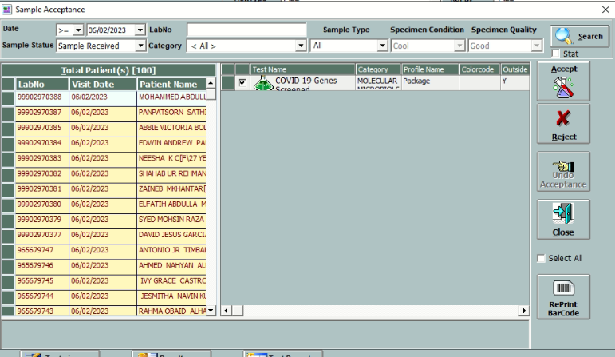

* After generation of Barcode, Sample is sent to work area, the concerned technologist accepts and checks the sample. After this click on accept sample button for sample acceptance.
* User can search Subject registration by putting request number in the req. no. column besides the date selection.
* User can search Subject by test category.
* Sorting of Subjects by sample status wise can be possible, default ‘COLLECTED’ will selected.
* Rejection can be done by user by putting appropriate reason. (E.g. Sample Haemolysed, Sample not sufficient etc.) Rejection details can be entered in the ‘Comment’ field.

